**INFS-417**

**CHAPTER 10- ASSIGNMENT 5**

**For the following exercises, work with the Framingham_training and Framingham_test data sets. Use only the Sex and Age fields. Standardize Age.**

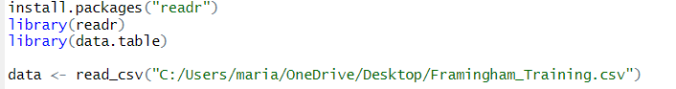

**18. Run k‐means clustering on the Framingham_training data set, requesting k = 2 clusters.**

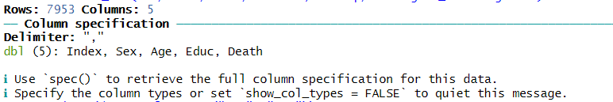

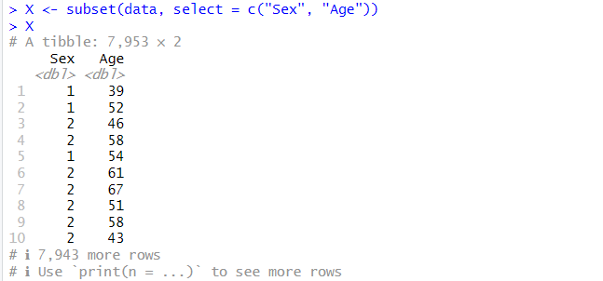

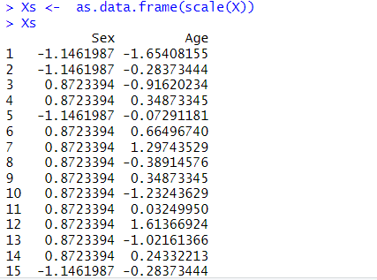

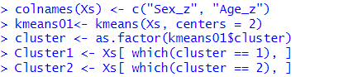

**19. Construct a table of statistics summarizing your clusters. Describe what these two clusters consist of.**

